**Memory Match Game in Windows Forms**

Gala Tomovska (171212)

1. **Introduction**
   1. **Project Overview**: Memory Match is an Application, created using Visual Studio – Windows Forms with C#, that depicts the famous Memory Game. It is a Single Player Game, so only one player can play at once.
   2. **Form dimensions**: 1000 x 700
   3. **How to play**: To Play, the Player need to click the “Play now” button, select a mode and click the “Start” button to start the game. Then, he/she can click on the fields with a question mark (2 at a time) and an image will appear. To win, the Player needs to match all images with their pair (the same image).
2. **Flow**

2.1) **Sequence Diagram**

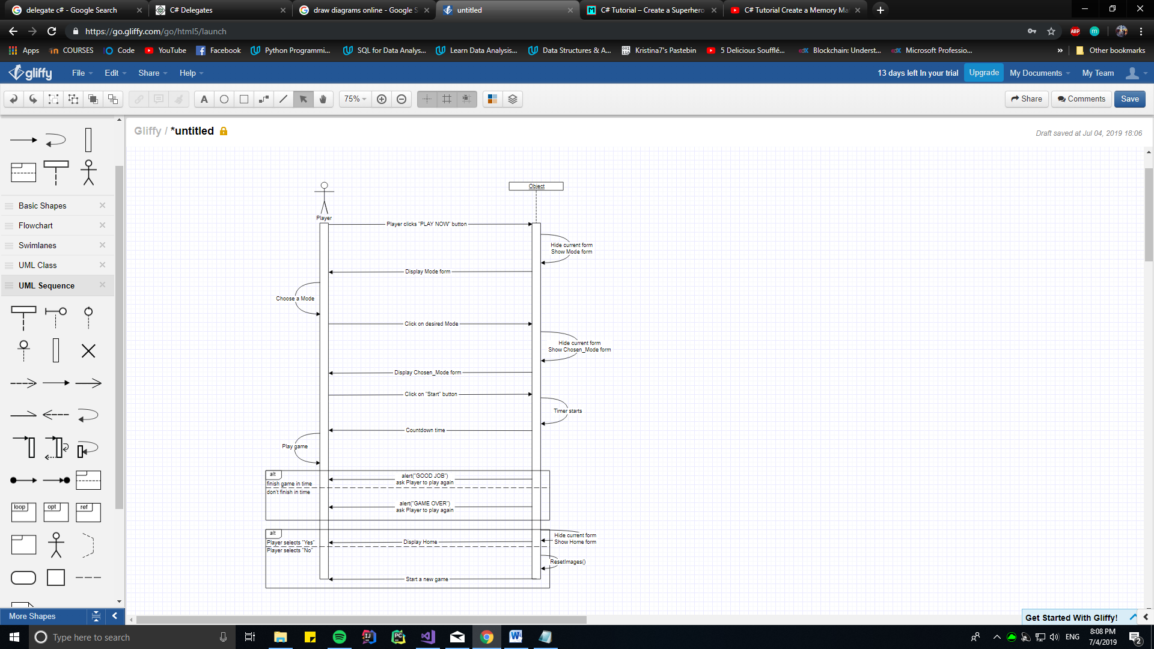

**Figure 1.** Sequence diagram

2.2) **Detailed Description**

The player, first, needs to click on the “Play now” button, located in the bottom right corner of the Welcome Page (see Figure 5).

After clicking the play now button, the Player will be redirected to the Mode form that displays buttons with game modes (see Figure 6). Each button selection will lead the Player to the selected Mode. There are three modes and three buttons respectively (top to bottom): KIDS, TEENS, and ADULTS.

Each selected mode shows a form that displays two buttons in the bottom left corner: “START” and “< SELECT MODE” (see Figure 7). Also, there are two labels that keep the clock timer and the number of moves. The clock label is preset to a certain value that depends on the Mode that the Player is in. The moves label is always preset to 0 before starting the game.

Clicking on the select mode button will return the Player to the Mode form where he/she can select another game mode.

Clicking on the START button will start the game:

The form will display 16 fields marked with a question mark (see Figure 8) in a 4 x 4 layout on the empty part of the screen. In the background, **images from an array**, one by one will randomly be placed on two of the 16 fields. Hence, there will be 8 images and 8 copies randomly placed each time the game starts. The player can view these images by clicking on a question mark field.

There can be, at most, two fields that show an image at any time. If the image in both fields is the same – the Player made a match and those fields will disappear. When opening the second image, the “number of moves” label, mentioned before, increments by one – keeping track of the Player’s total moves (see Figure 9).

If the Player does not manage to match two images, those images will “flip” and show the question mark fields again. This action will, also, increment the moves label.

There is a clock that starts at the same time the Player clicks the START button.

**The goal of the game** for the Player is to match all 8 images with their pair before the clock runs out. This is how the Player can “win” the game.

If the Player manages to win, a pop-up message box with a “Yes/No” choice will appear, asking the Player to play another round (see Figure 10).

If the Player selects “Yes” - the form will reset and the game will automatically start.

If the Player selects “No” - he/she will be redirected to the Welcome form.

If the Player does not manage to win and the clock runs out of time, another message box will appear with the same choice as described above.

galatomovska@gmail.com

Each click on a single field will play a sound that mimics a “card flip”.

**2.3) The modes**

* **Kids mode**: The time starts with 2 minutes on the clock; two selected images stay displayed for 500ms

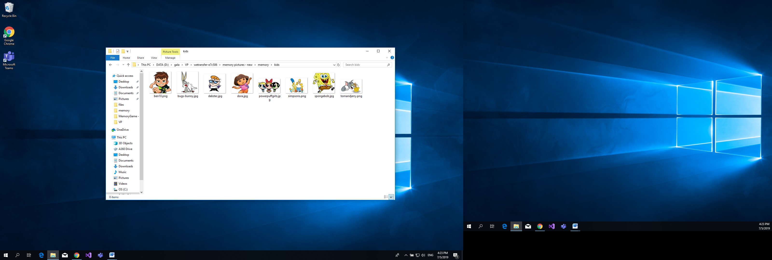

**Figure 2.** Images used in Kids mode

* **Teens mode**: The time starts with 1 minute on the clock; two selected images stay displayed for 300ms

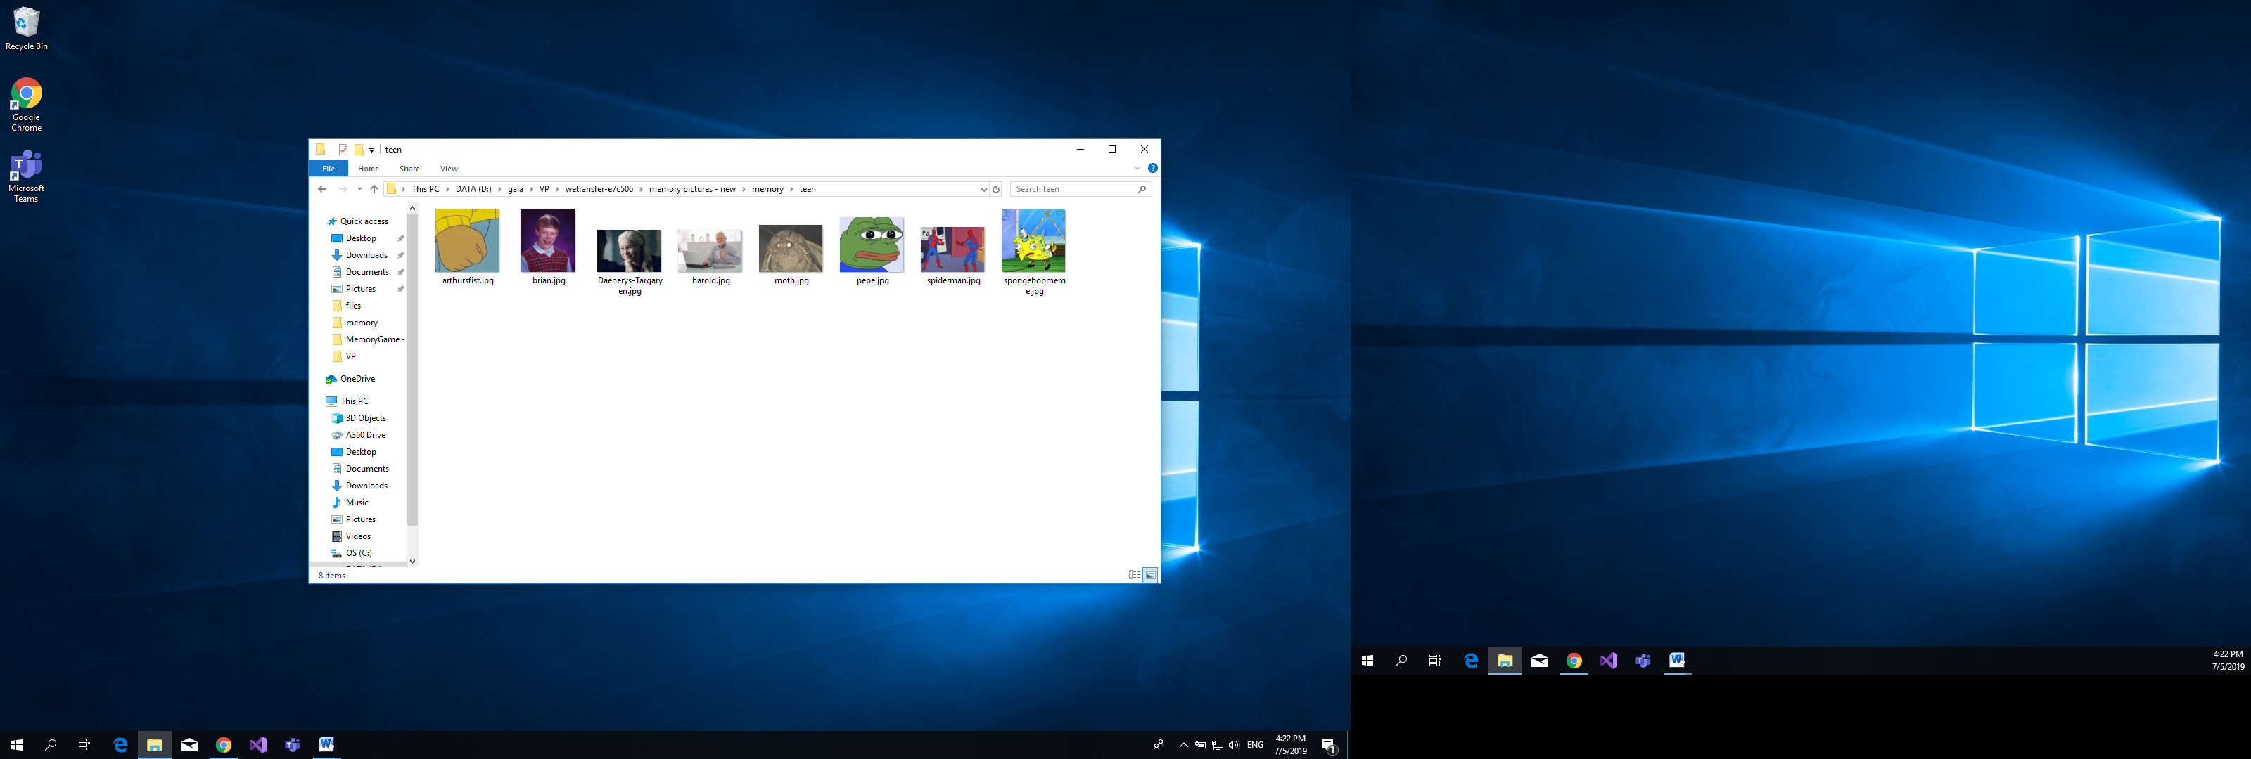

**Figure 3.** Images used in Teens mode

* **Adults mode**: The time starts with 2 minutes on the clock; two selected images stay displayed for 300ms

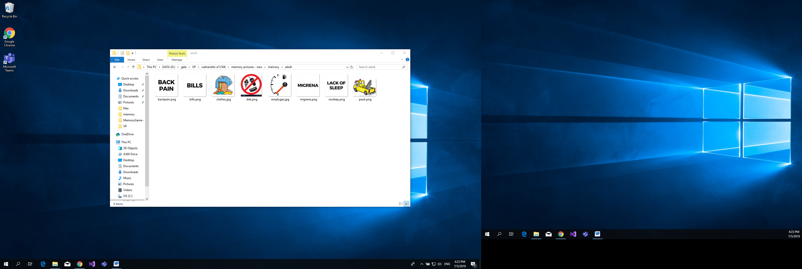

**Figure 4.** Images used in Adults mode

1. **Screenshots:**

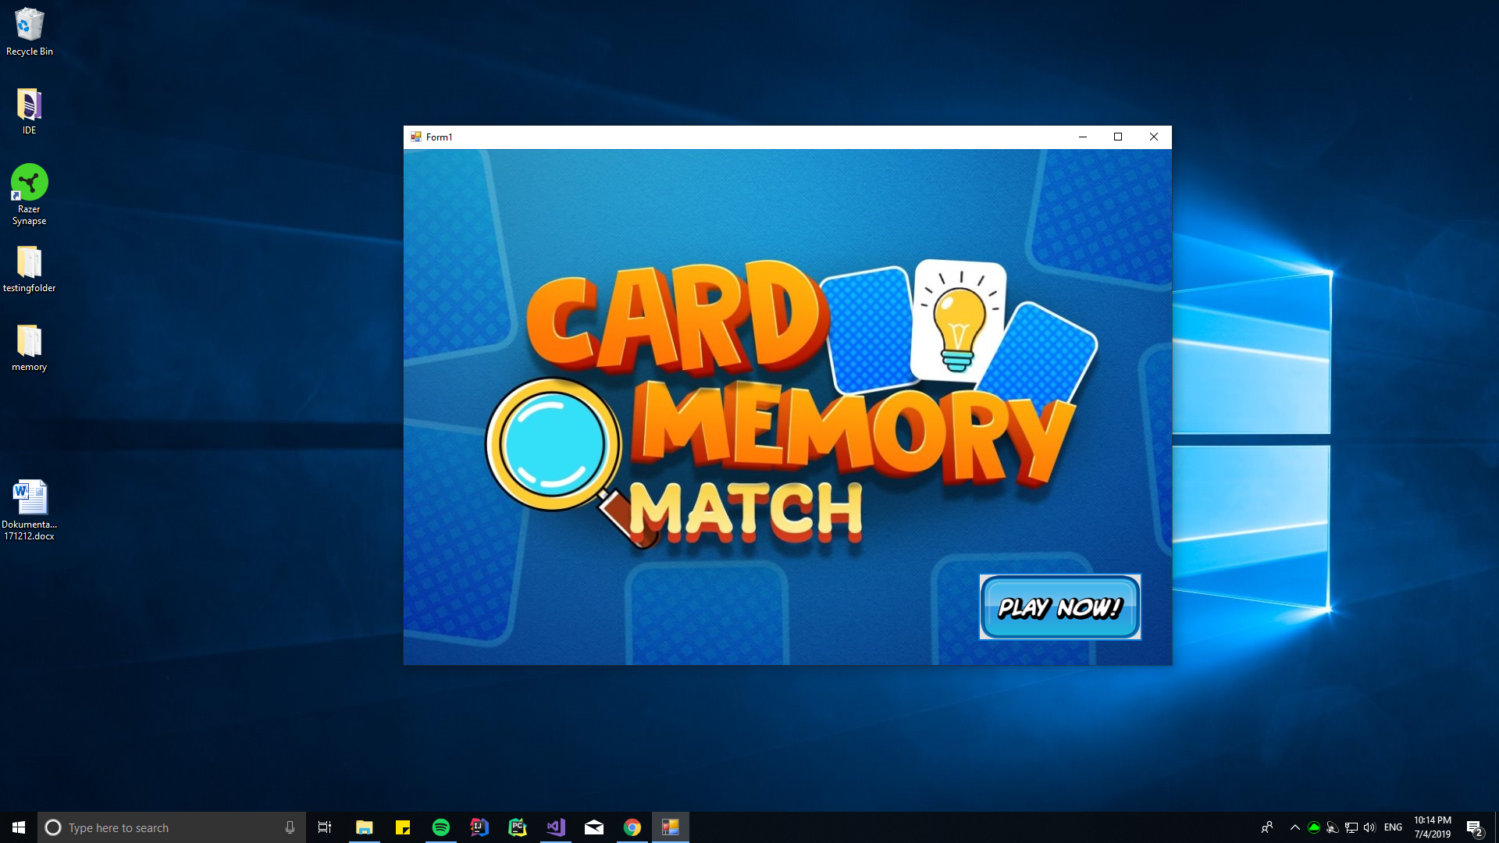**Figure 5.** Welcome Form

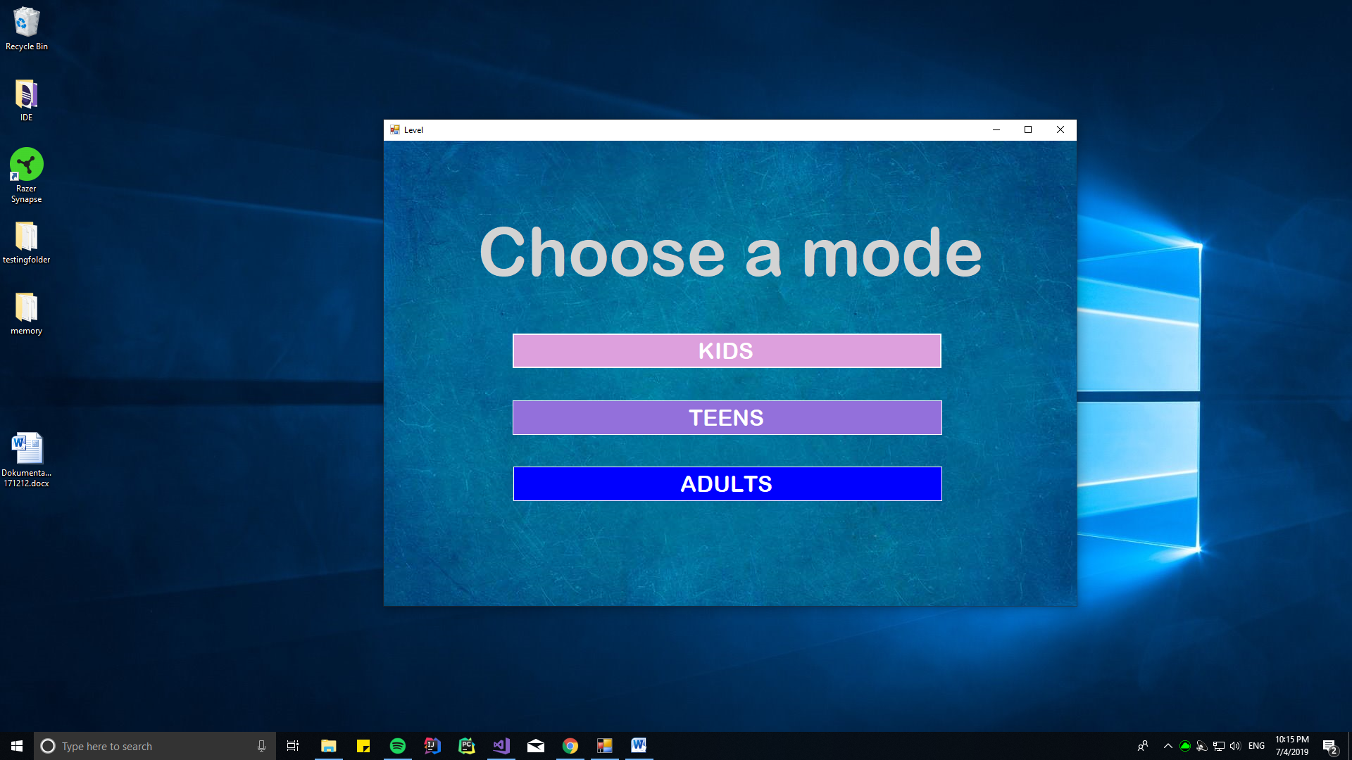

**Figure 6**. Mode Form

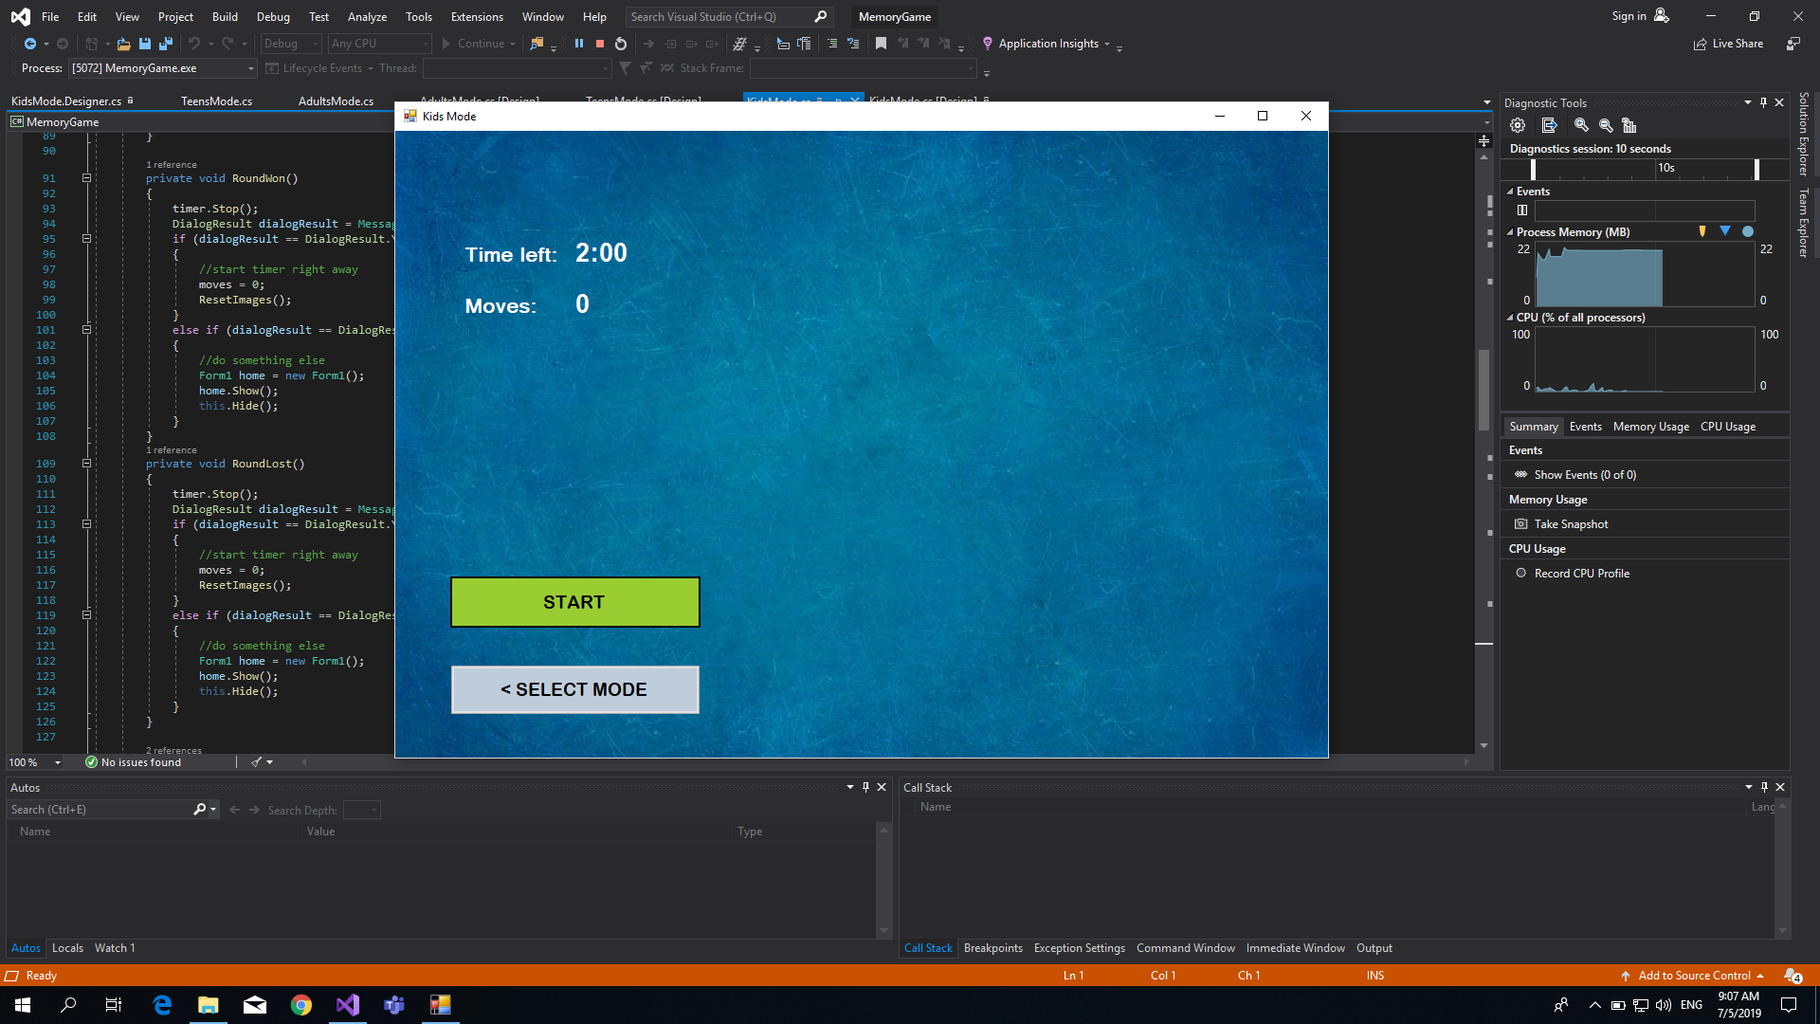

**Figure 7**. Selected Mode (not started yet)

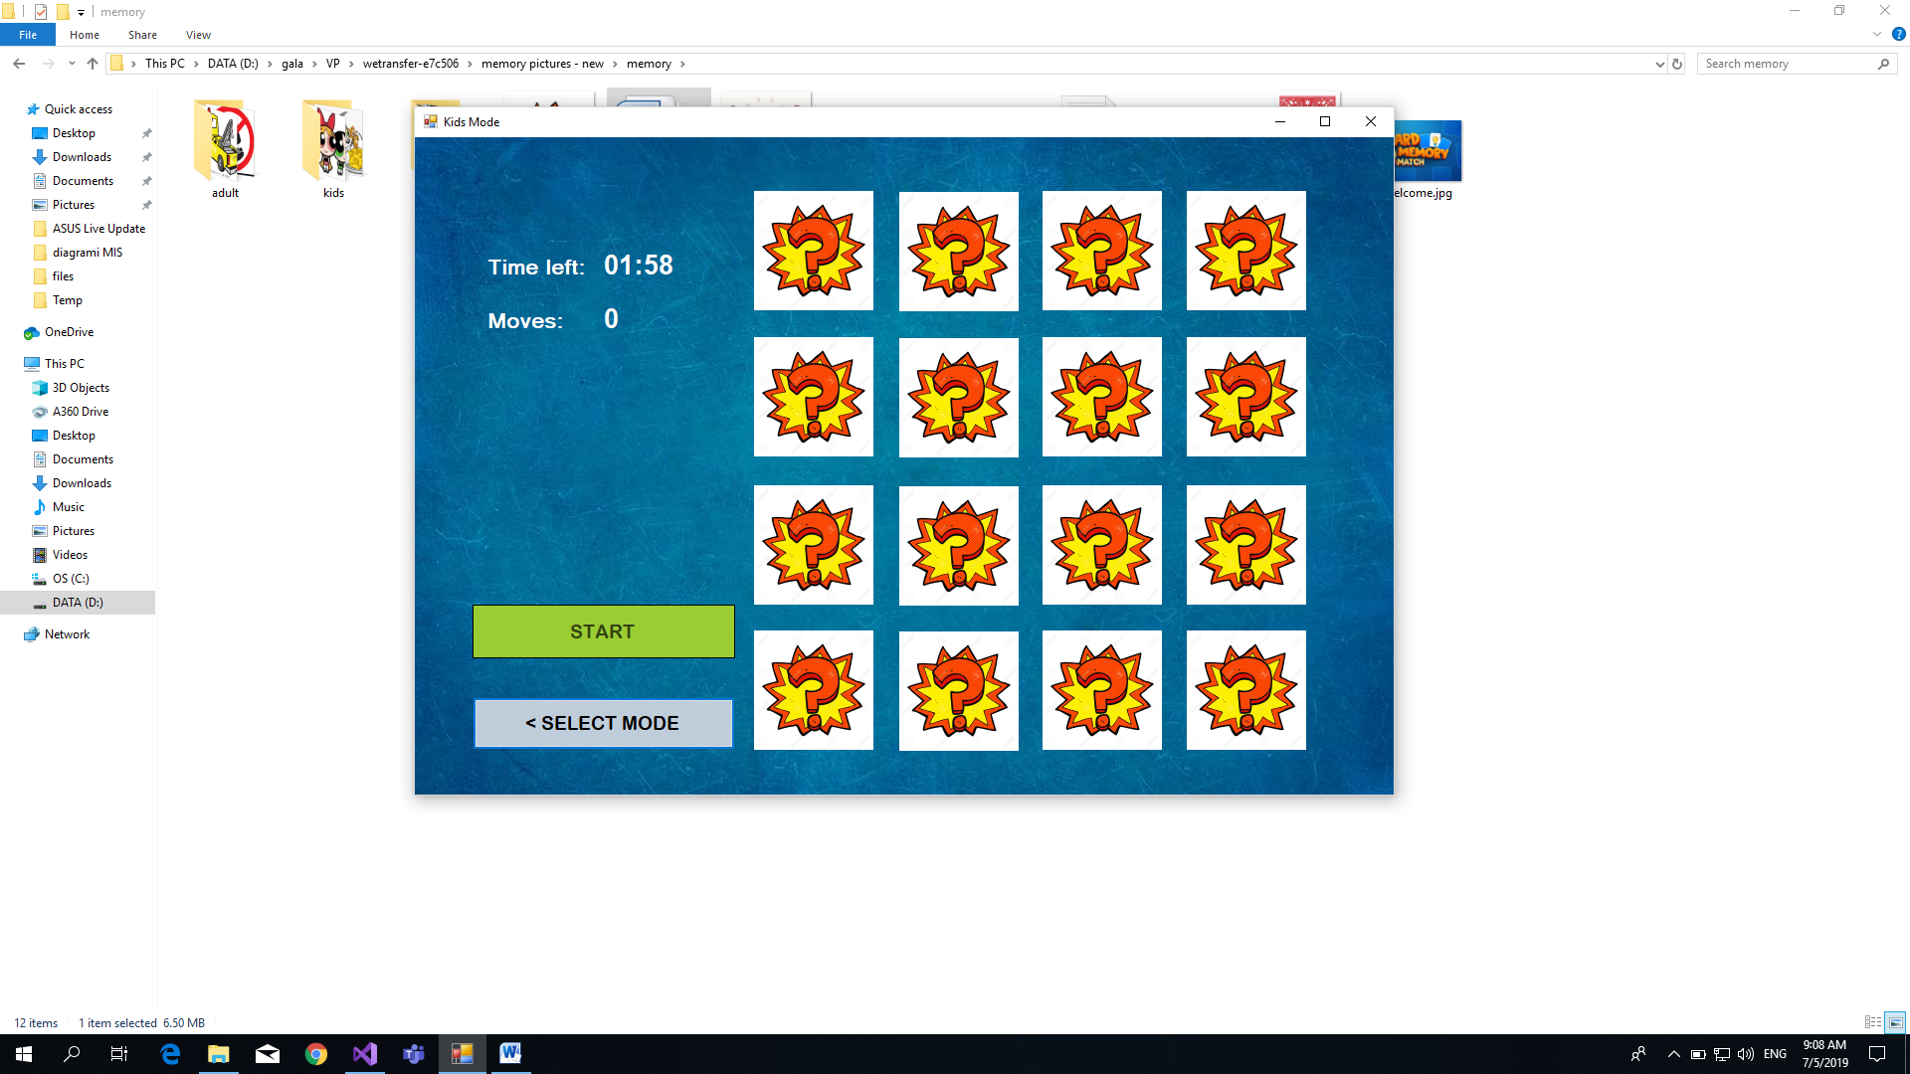

**Figure 8.** Click Start button

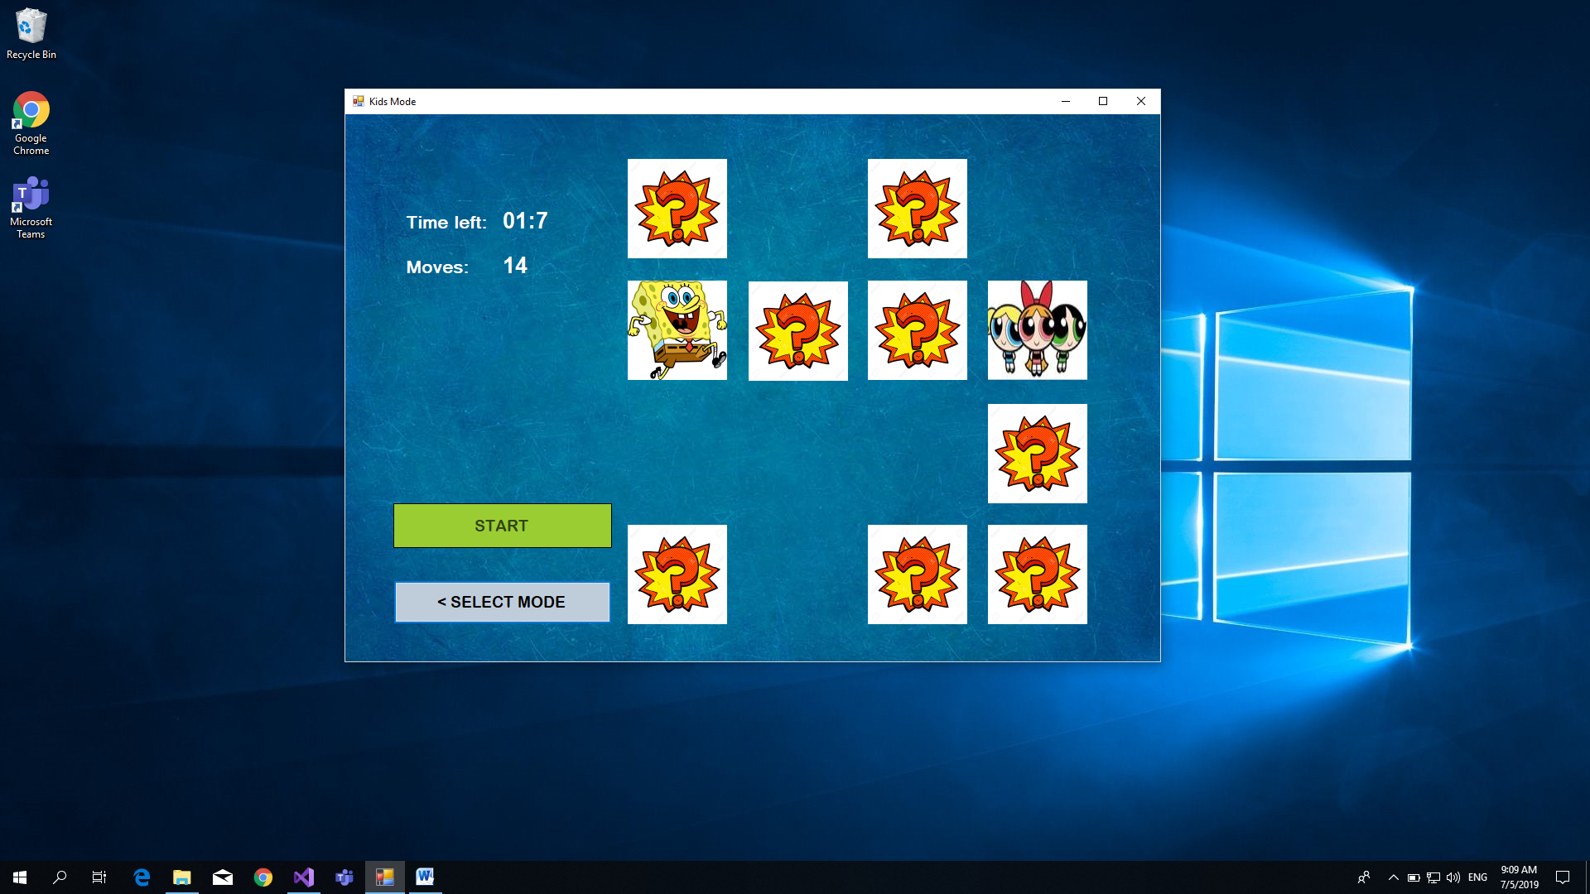

**Figure 9.** Mid-game

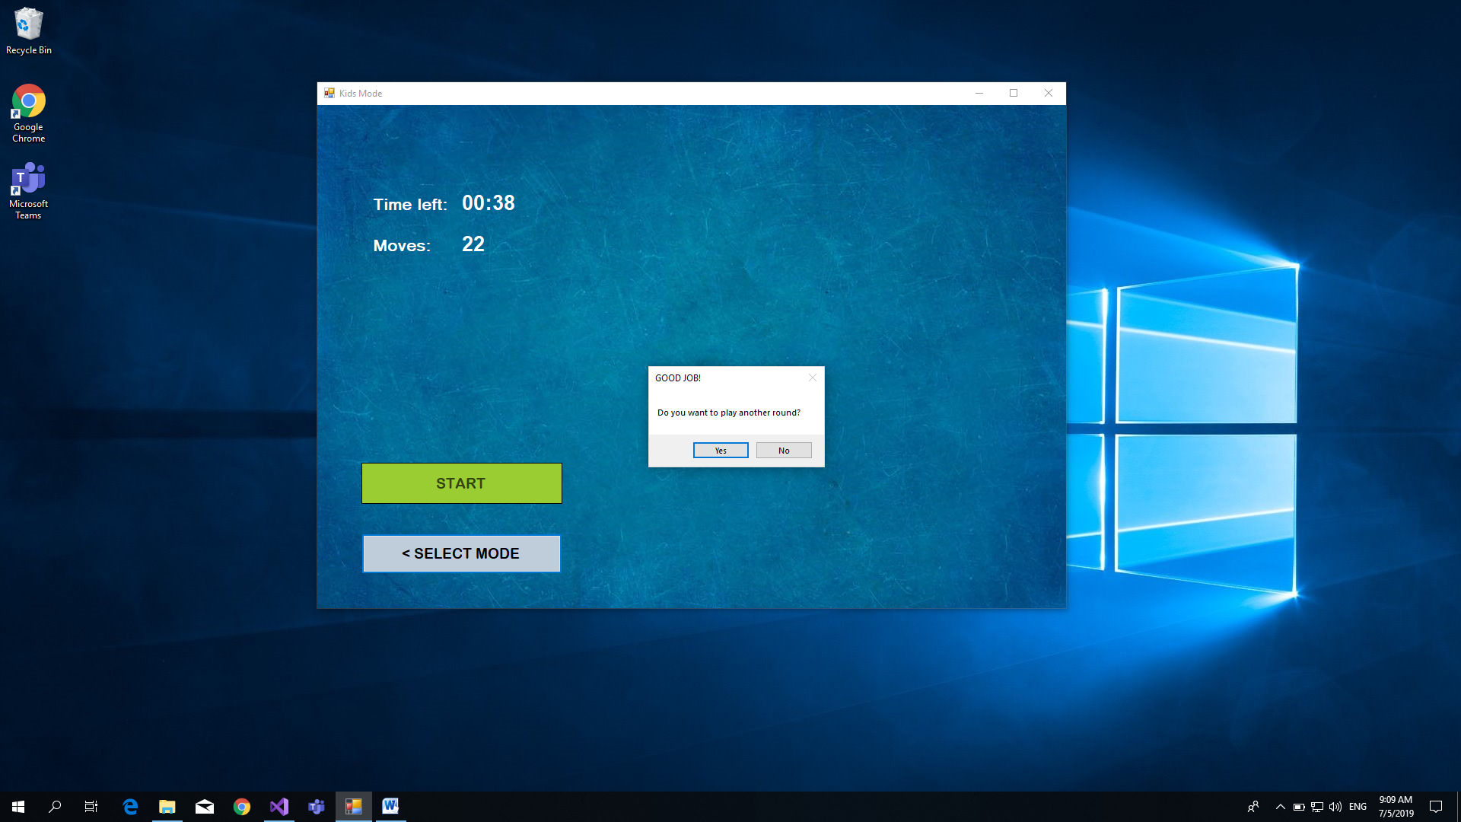

**Figure 10.** Game finished – Player won

1. **Code:**

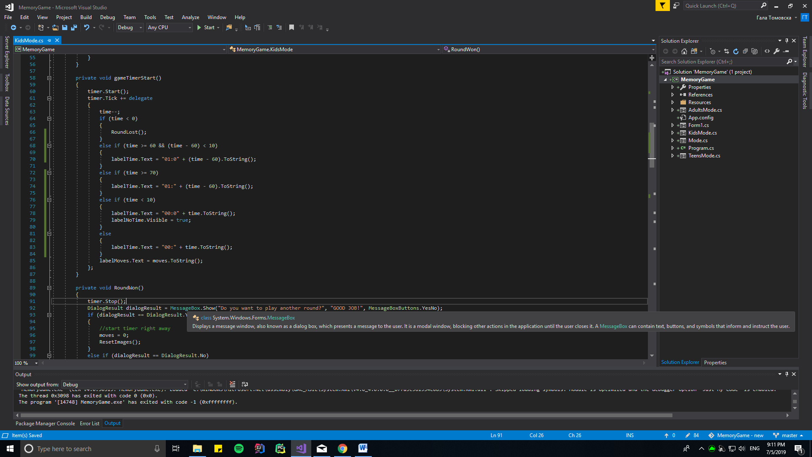

Figure 11. gameTimerStart() method

First, this function calls the method Start() on an instance of type Timer called timer with an Interval of value 1 sec. Then the “delegate” syntax is used. In C#, a delegate is used as a pointer, to point to a method – it is a reference type variable. Its reference can be changed during runtime. That is why a delegate is a perfect use for a countdown clock.

Each time the timer tics the delegate is called and does the following:

First, it decrements the time value by one (int variable that has a given value at the start of the game).

If the value of time gets bellow 0, the RoundLost() method is called (shows a MessageBox).

If time value is above or equal to 60, but bellow 70; the value is above or equal to 70; the value is below 60 the method manipulates the string that is shown in the Time label where the clock is displayed.

The same happened if the time value gets below 10, but a label to warn the Player that the time is about to run out shows on the screen (its Visible value is changed to true).